CASE STUDY
JeevanPath AI
Voice-First Livelihood Mapping & NSQF-Aligned Skilling Recommendations
PS 26097 | Ministry of Social Justice and Empowerment | Department of Social Justice and Empowerment
CORE CONCEPT
Voice → Understand → Profile → Analyse → Match → Explain → Track


1. INTRODUCTION
Livelihood and skilling programmes can be more effective when the training pathway reflects what a beneficiary already knows, what they want to do, what constraints they face and what opportunities are realistically available. For beneficiaries with limited digital exposure, language constraints or difficulty navigating text-heavy systems, the first barrier can occur before the training decision is even made.
PS 26097 calls for an AI-driven, multilingual, voice-based assistant capable of conversationally collecting beneficiary information and recommending suitable NSQF-aligned training and livelihood opportunities. The proposed case study translates that requirement into a practical software workflow rather than a generic chatbot.
JeevanPath AI is therefore designed as a domain-specific livelihood decision-support system. The conversational layer is used to understand the beneficiary, while structured profile data, skill-gap logic, verified qualification information, eligibility rules and opportunity data are used to produce an explainable livelihood pathway.
CENTRAL IDEA
The objective is not to answer a beneficiary’s question with a generic AI response. The objective is to convert a conversation into a structured, evidence-grounded pathway from existing capability to an actionable next step.

2. BACKGROUND OF THE CASE
The PM-AJAY GIA context combines livelihood promotion, skill development and income-generation activities. In practice, a useful digital system must operate across several realities at once: beneficiaries may have informal skills that are not documented in formal terminology; the same skill can be described differently across languages; and a relevant qualification on paper may not fit a person’s work preference, mobility or local context.
The proposed system therefore treats the beneficiary conversation as the start of a structured case, not the final interaction. The system builds a profile, validates missing information, interprets practical skills, analyses skill gaps, maps relevant qualification information and then presents an understandable pathway.
The architecture is intentionally modular. Voice access, speech recognition, conversational AI, the livelihood engine, qualification data and the opportunity layer are separated so that the system can be piloted with a small scope and extended later.


3. CASE STUDY OBJECTIVE
The main objective is to define and demonstrate a feasible voice-first software system that can translate a beneficiary’s natural-language responses into a structured livelihood profile and an explainable, NSQF-aligned pathway.
The objectives of JeevanPath AI are:
- Support conversational interaction through voice and simple text-based fallback.
- Collect beneficiary education, existing/traditional occupation, current livelihood, skills, interests, employment preference, mobility constraints and location-related preferences.
- Create a structured Beneficiary Livelihood Profile from conversational responses.
- Identify skill gaps between current capabilities and suitable livelihood pathways.
- Map relevant qualification information to the profile using verified NSQF/NQR reference data.
- Apply eligibility and preference rules before ranking pathways.
- Use verified regional opportunity information where reliable data is available.
- Explain why a pathway was suggested and what the next action is.
- Support low-connectivity and lightweight access through cached app/PWA features and queued synchronization where technically supported.
- Track referral, training and outcome states so the case does not end at the recommendation.

4. STAKEHOLDERS
Stakeholder | Role / Need | How the System Supports
SC Beneficiaries | Need accessible, understandable skilling and livelihood guidance. | Voice-first interaction, profile, pathway and next action.
Training Ecosystem | Needs better understanding of learner profile and requirements. | Structured skills, interests, constraints and pathway context.
Implementing Agencies | Need case visibility and follow-up. | Profile, referral, training and outcome status.
Programme Administrators | Need aggregate insight for planning and monitoring. | Privacy-conscious summaries of pathway demand and progress.
Training & Placement Stakeholders | Need relevant candidate-pathway information. | Eligibility, preference and skill-gap context where authorised.

5. PROBLEM IDENTIFICATION
The case analysis groups the practical problems into eight connected areas. These are presented as design problems for the proposed system, not as claims that each problem is unique to PM-AJAY.

5.1 Training–Livelihood Mismatch
A training option may not align with the beneficiary’s expectations, location preference, mobility, existing skills or desired work type.

5.2 Weak Skill & Aspiration Mapping
A beneficiary can describe practical experience or aspirations in natural language that does not directly map to formal qualification terminology.

5.3 Language & Digital Access Barrier
Text-heavy forms can make interaction difficult for users who prefer voice or regional-language conversation.

5.4 Skill-Gap Visibility Problem
Choosing a pathway without first identifying missing competencies can produce generic training recommendations.

5. PROBLEM IDENTIFICATION (CONTINUED)

5.5 Generic AI Recommendation Risk
A fluent LLM answer is not automatically an authoritative qualification, eligibility or opportunity decision.

5.6 Local Opportunity Relevance
A technically relevant qualification may still be less practical if the beneficiary cannot travel or if reliable local opportunity information is unavailable.

5.7 Recommendation-to-Action Gap
A list of courses is not the same as a clear pathway explaining what to do next.

5.8 Follow-up & Outcome Gap
Without case-state tracking, it is difficult to see whether the beneficiary moved from recommendation to referral, training or outcome.

6. USER PERSONA
Persona used for prototype evaluation; it is a synthetic scenario created for the case study and should not be represented as a real beneficiary.

Persona – Rural SC Beneficiary
Attribute | Illustrative Profile
Age / Context | Young adult beneficiary in a rural or semi-rural area
Education | Secondary-level education
Existing livelihood | Family-linked agriculture / practical work
Skills | Practical task experience without formal qualification terminology
Interest | Wants a better or more stable local livelihood
Employment preference | Open to wage employment or self-employment depending on fit
Mobility | Prefers opportunities close to home
Digital comfort | Can use a phone but may prefer voice over long text forms
Need | Clear recommendation with reason, gap and next action

Main Problems
- May not know which skill pathway fits existing practical experience.
- May not understand formal qualification terminology.
- May receive generic training information without local context.
- May find long text forms difficult to complete.
- May not know what to do after receiving a recommendation.

User Needs
- Voice-first interaction in a supported language.
- Short, adaptive questions rather than a long form.
- A structured profile that reflects practical skills and constraints.
- A clear skill-gap and qualification pathway.
- An understandable next action and follow-up status.



7. USER JOURNEY

BEFORE THE PROPOSED SYSTEM
- Beneficiary tries to understand available training or livelihood options.
- Information may be spread across forms, portals, people or local sources.
- Existing practical skills may be difficult to express in formal qualification terms.
- The beneficiary may select an option without a structured comparison of skills, constraints and preferences.
- There may be no simple pathway showing what happens after the recommendation.

WITH JEEVANPATH AI
- Beneficiary starts a voice/text interaction through a supported channel.
- The system asks adaptive questions and collects only the information needed for profiling.
- Speech/text is transformed into a structured Livelihood Profile.
- Skills and interests are normalized for reliable matching.
- The Skill-Gap Engine compares current capability with candidate pathways.
- Verified NSQF/NQR information is retrieved and eligibility/preferences are applied.
- Verified local opportunity data is used when available.
- The system generates an explainable pathway and delivers it through voice/simple visuals.
- The case can continue through referred, training and outcome states.



8. PROPOSED SOLUTION – JEEVANPATH AI
JeevanPath AI is proposed as a multilingual, voice-first livelihood decision-support system for beneficiaries under PS 26097. It combines conversational AI with structured livelihood data, qualification references, deterministic rules and semantic matching.
The basic concept is:
VOICE-FIRST LIVELIHOOD LOOP
Voice / Text → Speech/Language Processing → Structured Profile → Skill & Interest Analysis → Skill Gap → NSQF/NQR Mapping → Eligibility + Preference → Opportunity Layer → Pathway → Explain → Track

Core Design Principles
- Voice-first but not voice-only: text fallback is available for supported workflows.
- LLM-assisted, not LLM-controlled: the model supports conversation and extraction, while matching and eligibility are grounded in structured logic.
- Verified-data first: qualification and opportunity claims should carry a source/status where available.
- Constraint-aware: location, mobility, timing and work preference can influence ranking.
- Explainable: every recommendation should show why it fits, the gap and the next action.
- Offline-lite: selected profile capture, cached reference content and queued sync can be supported where the device/browser permits; heavy AI processing may still require connectivity.



9. SYSTEM WORKFLOW
The proposed workflow is deliberately explicit. Each stage has a clear responsibility and produces an output consumed by the next stage.
Workflow Step | Purpose
Step 1 – Beneficiary Input | Beneficiary speaks or enters simple text about education, livelihood, skills, interests, employment preference, mobility and location constraints.
Step 2 – Voice / Access Layer | Input can originate through mobile/web voice, voice note or an IVR-compatible channel. A lightweight app can cache the interaction shell and selected data.
Step 3 – Speech Recognition | Speech is converted to text. The selected language is retained for the conversational layer.
Step 4 – Conversational AI | The assistant asks adaptive questions, identifies missing information and extracts structured fields.
Step 5 – Structured Profile | The extracted attributes become a Beneficiary Livelihood Profile with confidence/confirmation status.
Step 6 – Skill & Interest Analysis | Existing skills, experience and interests are normalized to a common representation for matching.
Step 7 – Skill-Gap Engine | The system compares current capabilities with candidate livelihood pathway requirements.
Step 8 – NSQF / NQR Mapping | Relevant qualification information is retrieved from the verified qualification layer.
Step 9 – Eligibility + Preference Matching | Structured rules apply education/eligibility requirements and beneficiary preferences such as wage vs self-employment, location and mobility.
Step 10 – Verified Opportunity Layer | When reliable regional information exists, training, employment or self-employment opportunities can be attached to the pathway.
Step 11 – Pathway Ranking | Candidate pathways are ranked using profile relevance, skill gap, qualification data and stated constraints.
Step 12 – Explainable Recommendation | The system prepares pathway, reason, skill gap, qualification reference and next action.
Step 13 – Beneficiary Response | The result is provided through voice and a simple visual interface.
Step 14 – Follow-up / Outcome Tracking | The case can move through Profiled → Recommended → Referred → Training → Outcome.

10. ARCHITECTURE OVERVIEW

Layer | Main Components | Responsibility
Access Layer | React/PWA, voice input, voice note, IVR adapter | Simple beneficiary access, including lightweight/offline-lite interaction.
Language Layer | Speech recognition, LLM/NLP | Speech-to-text, conversational understanding, follow-up and extraction.
Profile Layer | Structured extraction, validation | Convert conversation into a reliable profile.
Matching Layer | Skill normalization, embeddings, rules | Normalize skills, identify gaps, filter eligibility and rank pathways.
Qualification Layer | NQR / verified NSQF-aligned data, RAG | Retrieve grounded qualification information.
Opportunity Layer | Verified regional data | Attach relevant opportunities where reliable data exists.
Application Layer | Python/FastAPI livelihood engine | Coordinates processing and business logic.
Data Layer | PostgreSQL + vector search | Profiles, cases, audit metadata and semantic search.
Tracking Layer | Case status + analytics | Follow-up, progress and outcome visibility.

11. TECHNICAL COMPONENTS
Component | Role in the Proposed System
React / PWA | Responsive interface and lightweight app-like experience.
Python / FastAPI | Backend services, orchestration and livelihood-engine processing.
Speech Recognition | Converts supported-language speech into text.
LLM / Conversational AI | Natural conversation, adaptive questioning and structured information extraction.
Embeddings / Semantic Search | Matches skills and qualification descriptions by meaning.
PostgreSQL | Stores structured beneficiary profiles, cases and audit metadata.
Vector Search (e.g. pgvector) | Stores/searches semantic representations for skill/qualification matching.
RAG | Retrieves relevant qualification context before generating explanations.
Rules Engine | Handles hard eligibility and preference constraints.
NQR / NSQF Reference Layer | Provides verified qualification information for mapping.
Opportunity Data Layer | Stores/consumes verified regional opportunity information when available.
Docker | Packages application services consistently for deployment.
Authentication / IAM | Controls secure access for beneficiary/staff/admin roles.

12. KEY FEATURES

12.1 Multilingual Voice Interaction
Conversational interaction through supported regional languages and voice-oriented access.

12.2 Adaptive Beneficiary Interview
Follow-up questions respond to what the beneficiary has already said instead of forcing a fixed long form.

12.3 Voice Livelihood Passport
A structured profile captures education, practical skills, experience, interests, work preference, mobility and location.

12.4 Skill Normalization
Different natural-language descriptions of similar practical skills are mapped to a common representation.

12.5 Skill-Gap Analysis
Current capability is compared with pathway requirements to identify missing competencies.

12.6 NSQF/NQR-Grounded Qualification Mapping
Qualification recommendations are retrieved from a verified reference layer rather than invented by the LLM.

12.7 Constraint-Aware Matching
Location, mobility and employment preference influence pathway ranking.

12.8 Opportunity Layer
Verified local opportunities can be attached when reliable data is available.

12.9 Explainable Pathway Card
Shows pathway, why it fits, skill gap, relevant qualification and next action.

12.10 Offline-Lite Operation
Selected reference data and profile capture can be cached locally; pending updates can be queued for later synchronization. Heavy cloud AI processing remains connectivity-dependent where on-device alternatives are unavailable.

12.11 Outcome Tracking
Tracks progress from profiling through referral, training and outcome.

13. USER EXPERIENCE DESIGN
The beneficiary-facing experience is designed to minimize typing and interpretation effort. The interface should make the system’s reasoning understandable without exposing unnecessary technical detail.

Beneficiary View
- Language selection / voice start
- Short conversational prompts
- Simple profile confirmation
- Skill-gap explanation
- Recommended pathway card
- Voice playback + readable summary
- Next action / referral status



Staff / Administrator View
- Beneficiary case lookup based on authorised access
- Structured profile view
- Recommendation and source status
- Referral/training/outcome status
- Aggregate pathway-demand insights
- Audit metadata and system version indicators

14. CASE STUDY SCENARIO
Consider a beneficiary who says: “I studied up to 10th. I have been helping my family with farming and can operate basic agricultural equipment. I want work near my village and I am open to learning a technical skill.” This is a synthetic scenario for illustrating the system workflow.

Stage A – Conversation
The assistant asks short follow-up questions about the current livelihood, experience, preferred work type, mobility and training availability. The user does not need to know formal qualification names.

Stage B – Structured Profile
Field | Extracted / Confirmed Value
Education | 10th
Current livelihood | Agriculture-linked practical work
Existing skill | Basic agricultural equipment operation
Experience | Family/work exposure
Preference | Local opportunity; technical skill interest
Mobility | Limited / local preference

Stage C – Skill Gap
The system compares the normalized skills with candidate livelihood pathways. It identifies which competencies appear to be present and which additional competencies would be required for each candidate pathway.

Stage D – Qualification Mapping
The qualification layer retrieves relevant verified records. The LLM is not treated as the authoritative source for qualification titles, levels or eligibility.

Stage E – Ranking
Eligibility and preference rules filter unsuitable options. Semantic similarity can help rank the remaining pathways according to the beneficiary’s stated skills and goals.

Stage F – Explainable Output
EXAMPLE OUTPUT STRUCTURE
Recommended pathway → Why it fits → Existing skills → Skill gap → Relevant qualification reference → Next action

Stage G – Follow-up
The case can transition from “Recommended” to “Referred”, “Training” and finally “Outcome” when the relevant status information is available.

15. WHY THIS IS NOT JUST CHATGPT / GEMINI
General-purpose conversational AI can already handle voice and natural-language interaction. Therefore, the project should not claim that “AI voice chatbot” itself is the innovation. The differentiator is the domain-specific workflow and control layer around the conversation.
General-Purpose AI | JeevanPath AI
Conversation | Conversation + beneficiary case workflow
General response | Structured livelihood profile
Prompt-dependent advice | Skill-gap engine + pathway rules
Generic knowledge | Verified qualification reference layer
May answer a course question | Maps current capability to a pathway
No dedicated PM-AJAY workflow | PM-AJAY-focused use case and case states
Generic context | Explicit location, mobility and work-preference fields
Response may end the session | Profile → referral → training → outcome tracking
Model-generated details can be plausible | Qualification/eligibility details are grounded in structured data and rules

THE CORE DIFFERENTIATION
LLM = Conversation + Understanding + Extraction | Domain Engine = Verification + Matching + Pathway + Tracking

Design Rule
The LLM should not independently decide formal qualification eligibility or invent local opportunity availability. The system should retrieve relevant verified information and apply deterministic checks before presenting a recommendation.

16. IMPACT ANALYSIS

Beneficiary Impact
- Lower interaction burden through voice-first access.
- More personalised guidance based on skills, aspirations and constraints.
- Clearer visibility into skill gaps and next actions.
- Potentially better relevance of pathways because location and mobility can be considered.

Training Ecosystem Impact
- Structured beneficiary information can provide a clearer picture of skills and preferences.
- Training pathway requirements can be compared with existing skills before referral.

Implementing Agency Impact
- Structured profiles and case states support follow-up.
- Aggregate views can show pathway demand and case progress without exposing unnecessary personal data.

Programme Monitoring Impact
- The pathway state can support visibility from recommendation to training/outcome.
- Validated feedback can later support improvement of pathway ranking.

Real-Life Benefits
Before | Proposed With System
Long or fragmented information collection | Conversational information collection
Practical skills expressed informally | Structured skill representation
Generic course browsing | Profile + skill-gap pathway matching
Recommendation without context | Recommendation with reason and next action
Limited follow-up visibility | Case-status tracking

17. CHALLENGES AND LIMITATIONS
Challenge | Risk | Mitigation
17.1 Speech / Language Accuracy | Accents, dialect variation, background noise and language coverage can affect speech recognition. | Use confidence scoring, confirmations, representative testing and language-specific vocabulary.
17.2 Qualification Data Freshness | Qualification or eligibility information can change. | Version and timestamp the reference dataset; refresh it periodically.
17.3 Local Opportunity Data | Employment or training availability may be incomplete or change rapidly. | Use source, status and update date; show “unverified/unavailable” rather than guessing.
17.4 Recommendation Bias | Ranking criteria can unintentionally over-favour some pathways. | Keep criteria explainable, auditable and reviewable.
17.5 Privacy | Beneficiary data may contain personal information. | Collect minimum necessary data, use access controls and encryption, and define retention.
17.6 Connectivity | Voice/LLM services may require network access on some devices. | Use an offline-lite mode: cached app, local profile capture, selected cached reference data and queued synchronization.
17.7 On-Device AI Limits | Full local speech/LLM processing may not be available on every phone. | Treat on-device models as device-dependent optimization; retain a low-bandwidth online fallback.
17.8 Validation | A prototype should not claim recommendation accuracy without testing. | Use labelled profiles, expert validation and measured KPIs before reporting numerical performance.

18. SUCCESS METRICS
The following metrics are proposed for prototype validation. Numerical targets should be added only after controlled testing.
Metric | What to Measure
Voice Completion | Share of test sessions completed through the voice flow.
Profile Completeness | Required profile fields correctly captured/confirmed.
Speech Performance | Recognition performance on the supported test languages and conditions.
Skill Normalization | Correct mapping of varied expressions to normalized skills.
Skill-Gap Validity | Expert agreement on identified missing competencies.
Qualification Mapping Validity | Whether each mapped qualification matches the verified reference record.
Eligibility Precision | Rate of valid vs invalid pathways after rule filtering.
Recommendation Relevance | Expert/user rating of pathway relevance.
Explanation Comprehension | Whether users understand why the pathway was suggested.
Response Latency | Time from input to usable response under test conditions.
Offline-Lite Operation | Profile capture and queued-sync behaviour under constrained connectivity.
Outcome Tracking Reliability | Correct transition between case states.

19. EXPECTED OUTCOME
The expected outcome is a functional software prototype demonstrating the complete livelihood-assistance loop from beneficiary conversation to an explainable, NSQF-aligned pathway and follow-up state. The prototype should demonstrate that conversational AI can be integrated with structured qualification data and business rules rather than used as a standalone chatbot.
The prototype is expected to demonstrate:
- Multilingual voice/text intake for selected supported languages.
- Automatic conversion of conversation into a structured Beneficiary Livelihood Profile.
- Skill and interest normalization.
- Skill-gap analysis.
- Verified NSQF/NQR qualification retrieval for selected records.
- Eligibility and preference filtering.
- Explainable pathway generation.
- Simple voice and visual beneficiary response.
- Offline-lite profile capture / local caching where supported.
- Follow-up and case-outcome tracking.
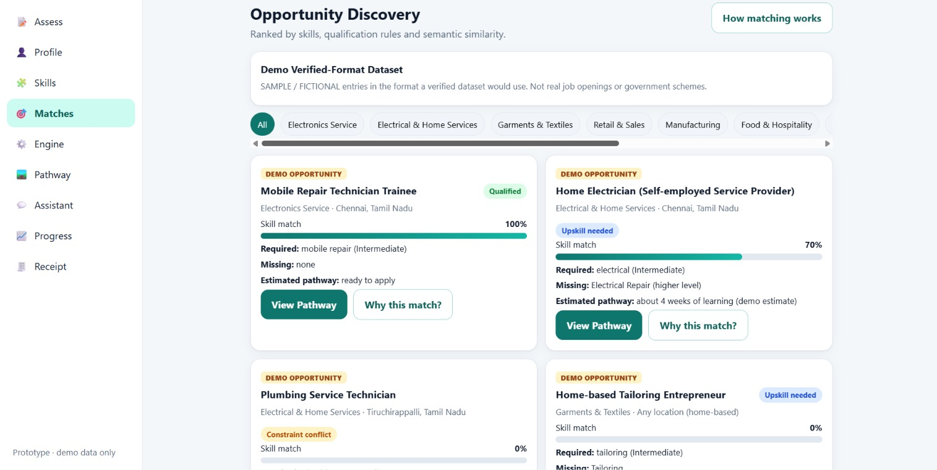

20. CONCLUSION
The PS 26097 case study proposes a livelihood-assistance system in which voice interaction is the entry point, not the final product. The central technical challenge is to translate natural conversation into a reliable structured profile and then use that profile to produce a grounded, explainable livelihood pathway.
The proposed architecture combines conversational AI, speech processing, skill normalization, semantic matching, RAG-based retrieval, verified qualification data, deterministic eligibility rules, opportunity data and case tracking. The design intentionally separates the responsibilities of the LLM from the responsibilities of the livelihood decision-support engine.
The system also acknowledges practical deployment constraints. A lightweight and offline-lite design can reduce connectivity dependence for selected tasks, while heavier speech/LLM processing may use online services when the device cannot perform those tasks locally. This keeps the architecture realistic rather than claiming fully offline AI capability on every phone.
The central idea can be summarized as:
TAGLINE
VOICE → UNDERSTAND → PROFILE → ANALYSE → MATCH → EXPLAIN → TRACK

Five Connected Requirements
- Voice-first accessibility
- Structured livelihood profiling
- Skill-gap + NSQF/NQR alignment
- Verified and explainable pathway matching
- Follow-up and outcome visibility

21. CASE STUDY SUMMARY
Item | Case Study Summary
Problem | Beneficiaries may face barriers in discovering and navigating a suitable skill-to-livelihood pathway; information may be generic, text-heavy or disconnected from practical constraints.
Primary Users | SC beneficiaries under the PS 26097 use case, with supporting roles for training, implementing and programme-monitoring stakeholders.
Core Challenges | Training-livelihood mismatch, weak skill mapping, language/digital barriers, unclear skill gaps, generic AI risk, local relevance, action gap and follow-up gap.
Proposed Solution | JeevanPath AI – a multilingual, voice-first livelihood decision-support workflow.
Main Workflow | Beneficiary → Voice → ASR → Conversational AI → Structured Profile → Skill Normalization → Skill Gap → NSQF/NQR → Eligibility/Preference → Verified Opportunity → Pathway → Explain → Outcome.
Core Technologies | React/PWA, Python/FastAPI, speech recognition, LLM/NLP, embeddings, PostgreSQL/vector search, RAG, rules engine, verified qualification data and secure access.
Unique Differentiation | The LLM is only one layer; the domain engine controls structured profiling, verification, matching, pathway generation and outcome tracking.
Offline-Lite | Selected app/profile/reference functions can operate locally with queued synchronization; heavy AI processing remains dependent on device capability/connectivity.
Expected Impact | Easier access, more personalised guidance, clearer skill gaps, better pathway context and stronger follow-up visibility.
Validation | Use measured profile completeness, mapping validity, recommendation relevance, explanation comprehension, latency, connectivity and outcome-tracking metrics.
Expected Outcome | A functional prototype demonstrating an evidence-grounded, explainable livelihood pathway loop rather than a generic chatbot.

22. RECOMMENDED DEMONSTRATION SCRIPT
- Start with a beneficiary speaking in a selected supported language.
- Show the adaptive follow-up question sequence.
- Display the structured Livelihood Profile created from the conversation.
- Show normalized skills and the identified skill gap.
- Retrieve a selected verified qualification record from the reference dataset.
- Demonstrate eligibility and preference filtering.
- Show the Explainable Pathway Card.
- Play the answer as voice and show the same information visually.
- Demonstrate the Profiled → Recommended → Referred → Training → Outcome case states.
- Demonstrate offline-lite behaviour using cached profile capture and later sync on the prototype where supported.
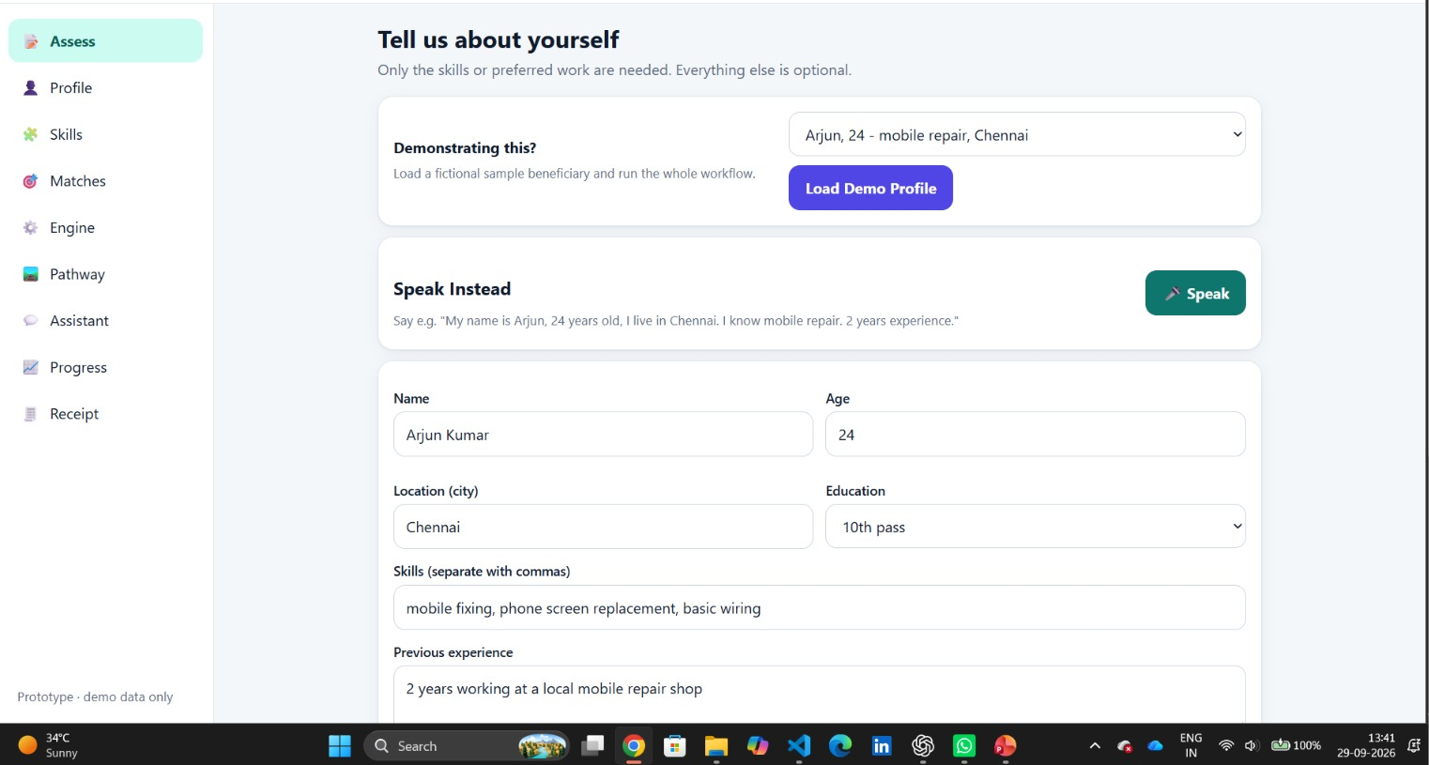

23. R&D GUARDRAILS
- Do not describe the system as a generic chatbot.
- Do not allow the LLM to invent qualification, eligibility or opportunity facts.
- Do not show a local opportunity as verified without a reliable source and update status.
- Do not claim employment improvement before measuring it.
- Do not promise full offline AI on every device; describe offline-lite functionality accurately.
- Keep the system modular so language, qualification and opportunity layers can be updated independently.
- Keep beneficiary data minimal, secured and access-controlled.
- Record model/rule/data versions for important recommendation decisions.

24. REFERENCE NOTES
The case-study structure and level of detail intentionally follow the uploaded CASE STUDY template: introduction, background, objective, stakeholders, problem identification, user persona, user journey, proposed solution, system workflow, key features, user experience, scenario, impact analysis, challenges, success metrics, expected outcome, conclusion and case-study summary.
For PS 26097-specific facts, qualification references and scheme details, the final presentation should cite the official problem statement and authoritative Government of India / NQR sources used by the team. This document keeps prototype architecture and validation claims separate from those external facts.



